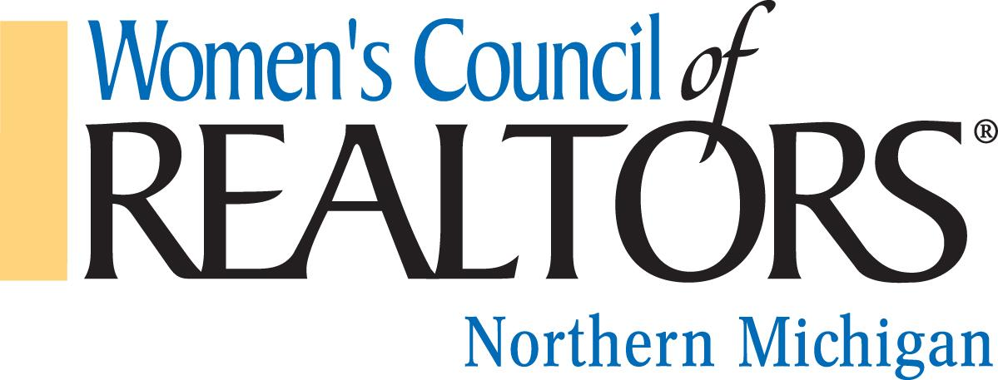

We are a network of successful REALTORS® advancing women as business leaders in the industry and in the communities we serve.

Governing Board Meeting, Thursday, October 12, 2023 Hagerty Center
Chairman, Jennifer Gaston, President

Call to order – Jennifer Gaston
Approval of Minutes for September 7, 2023
Approval of Agenda, October 12, 2023

Reports from Officers, Chairs and Project Teams

President’s Report: Jennifer Gaston
- Discuss November Luncheon: Dave Eisner, Brayton Farr/Cardinal Financial
sponsors, charities, etc.
- State Event: Be Motivated Tuesday, October 24 9:00 to 4:30 Frankenmuth Brewery.
State Board has opened registration to anyone who may be interested in joining the BOD.
- Northern Received our Network Certification!
- Brain Trust was a huge success. We receive a multitude of ideas for great programming in 2024.
- Strategic Planning Meeting October 26 at Kelly Price’s home. Discuss printing costs.
- Meet with on Oct. 30th TCGCC to discuss rooms and table placement.

President Elect: Kelly Price
- Review of Fall meeting in Detroit
- Discuss Strat Plan

Treasurer Report, Budget & Finance: Brandi Wolf
- Current Budget

First Vice President: Aubrey Vandemark
- Minutes

Program Director: Carly Tunison
- Update on Marketing needs for upcoming events.

Membership Director: Chair: Clover Keys Roy
- Membership Update

Committee Reports:
Other Committees: Swag Fundraiser starts today and runs until Oct. 29^{th.}
The holiday party needs volunteers.

Unfinished Business/New Business

Adjourned: Next Board Meeting to be November 9, 2023, 9:45 Hagerty Center

