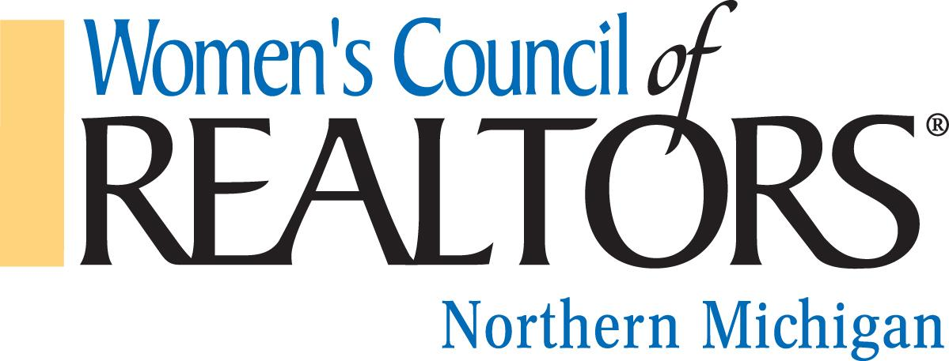

We are a network of successful REALTORS® advancing women as business leaders in the industry and in the communities we serve.

Governing Board Meeting, Thursday, February 9, 2023, 9:30 Hagerty Center
Chairman, Jennifer Gaston, President

Call to order – Jennifer Gaston
Approval of Minutes for January 12, 2022
Approval of Agenda, February 9, 2023

Reports from Officers, Chairs and Project Teams

President’s Report: Jennifer Gaston
- Northern’s business plan was submitted to the State prior to January meeting.
- The State would like us to change our Standing Rules regarding how the Realtor and Strategic Partner of the Year are chosen. They want the nominees to be voted on by the BOD, rather than by committee.
- Most of the BOD attend the State’s ‘Be Inspired’ event on January 25, 2023.
- Finalize day, time, and length of future board meetings.

President Elect: Kelly Price
- Update on bookmarks

Treasurer Report, Budget & Finance: Brandi Wolf
- Current Budget
- New Debit Cards for Pres. PE and Treasurer

First Vice President: Aubrey Vandemark
- Minutes

Program Director: Carly Tunison
- Update on Marketing

Membership Director: Chair: Clover Keys Roy
- Strategic Partner & Realtor® Member count
- Membership Updates/Feedback to share

Committee Reports:
Home Tour: Chair: Rene Hills to discuss changing the time of the Home Tour.
Update on Preferred Book Distribution: Brandi Wolf, Jackie Duncan and Troy Gahm to be selling ads in the book.
Other Committees:

Unfinished Business

New Business

Adjourned: Next Board Meeting TBA

