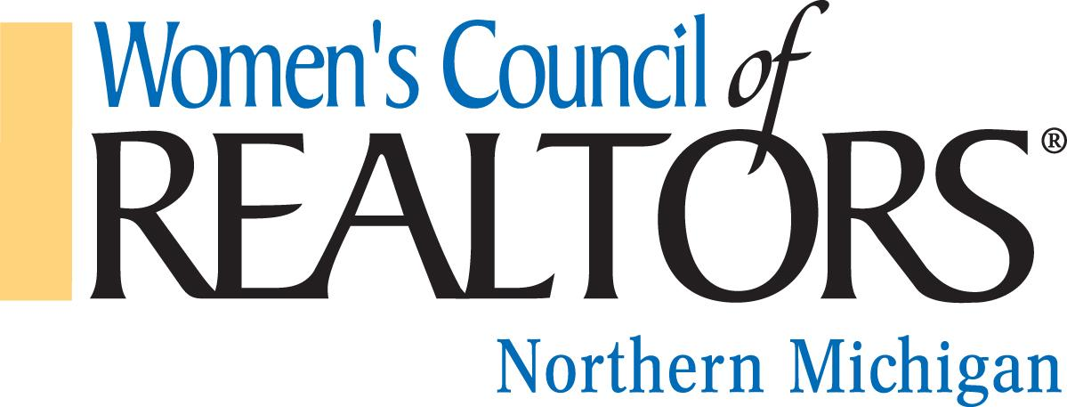

We are a network of successful REALTORS® advancing women as business leaders in the industry and in the communities we serve.

Governing Board Meeting, Thursday, May 18, 2023, 9:45 Hagerty Center
Chairman, Jennifer Gaston, President

Call to order – Jennifer Gaston
Approval of Minutes for April 13, 2022
Approval of Agenda, May 18, 2023

Reports from Officers, Chairs and Project Teams

President’s Report: Jennifer Gaston
- Update members on Mid-Year Conference in Washington DC
- Name Tags will be ordered for the incoming board.
- Be Connected State event is June 28 - 30

President Elect: Kelly Price
- Medical Leave

Treasurer Report, Budget & Finance: Brandi Wolf
- Current Budget
- Preferred Directory Update

First Vice President: Aubrey Vandemark
- Minutes

Program Director: Carly Tunison
- Update on Marketing

Membership Director: Chair: Clover Keys Roy
- Membership Update

Committee Reports:
Home Tour: Chair Rene Hill. Discuss changing the time and venue of the tour.
Other Committees:

Unfinished Business

New Business

Adjourned: Next Board Meeting to be 9:45 on June 15th, 2023, Location TBD

