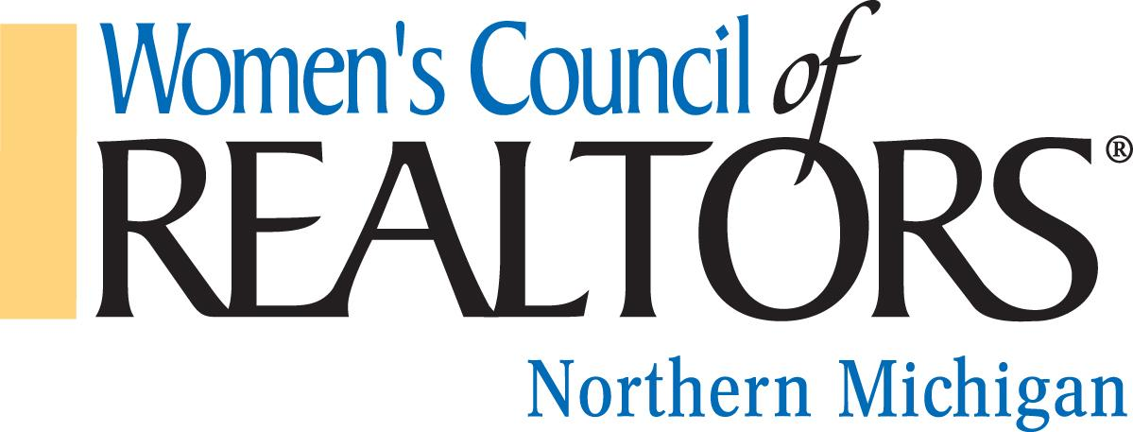

We are a network of successful REALTORS® advancing women as business leaders in the industry and in the communities we serve.

Governing Board Meeting, Thursday, June 15, 2023, 9:00 REMAX Bayshore
Chairman, Jennifer Gaston, President

Call to order – Jennifer Gaston
Approval of Minutes for May 18, 2022
Approval of Agenda, June 15, 2023

Reports from Officers, Chairs and Project Teams

President’s Report: Jennifer Gaston
- Name Tags have been ordered for the incoming board.
- Be Connected State event is June 28 – 30. Number of Northern members attending? Discuss Transportation.
- Property Tour – possible location Meadow Valley https://youtu.be/md1dRsmoj5M
- Preferred Directory Distribution

President Elect: Kelly Price
- Bookmarks
- Rove Vineyard Strategic Partner Event Aug. 17th. Work on finding Sponsors.

Treasurer Report, Budget & Finance: Brandi Wolf
- Current Budget

First Vice President: Aubrey Vandemark
- Minutes

Program Director: Carly Tunison
- Update on Marketing

Membership Director: Chair: Clover Keys Roy
- Membership Update

Committee Reports:
Other Committees: Merchandise Fundraising event at our October 12th luncheon.

Unfinished Business

New Business

Adjourned: Next Board Meeting to be 9:00 on July 15th, 2023, Location TBD

